ASSIGNMENT 3

Degree of Maturity Recognition

Dániel Grimm – 2021163965

Anthony Laperche – 2021189749

1. Pre-processing Image:

We start with many seed’s images, and our goal it’s to transform this image to only keep the seed. We used a Gabor filter and after filtering we get this type of images:

The image is now pre-process and we can keep only the pixels that are useful of the recognition.

After that we used a function to extract data from the pictures as %%%% IR %%%%

To start our fuzzy system, we have studied the average data value of each class. That gives us:

RED GREEN BLUE Entropy R-G B-R G-B

As we can easily recognize a seed’s class with his average of green colour and his difference between red-green and green blue.

1. Fuzzy Recognition

One of our fuzzy system as been created by hand it’s a Sugeno system with 6 rules we obtain this result we tried the fuzzy system on all the data :

After that we have created Mamdani train with pre-process data. We have created two data set one for testing and the other for training like follow:

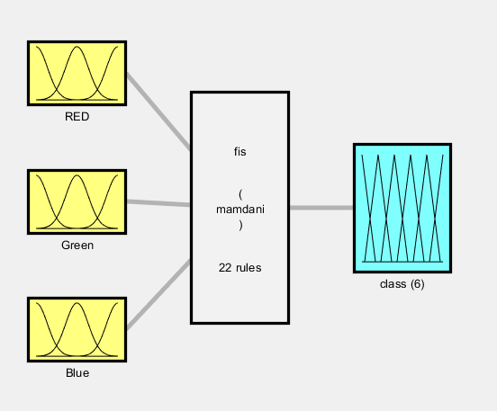

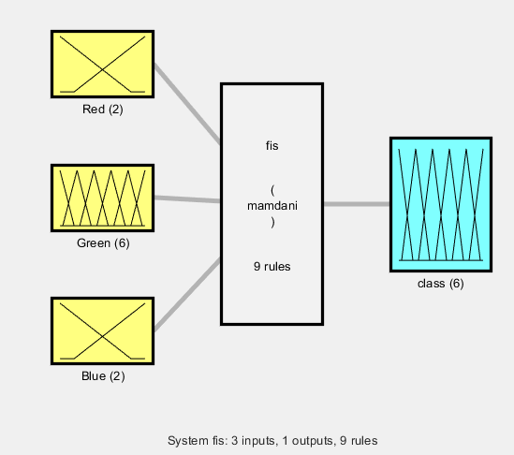 Like each machine learning project, the amount of data used increased the performance of the fuzzy system. We have decided to put more MF in the green colour because this colour change a lot with the different class.

The result obtain are quite low, below 60%. This can be caused by a bad processing or a bad implementation of our Mamdani system.

As we can see with more rules the fuzzy system is not better.

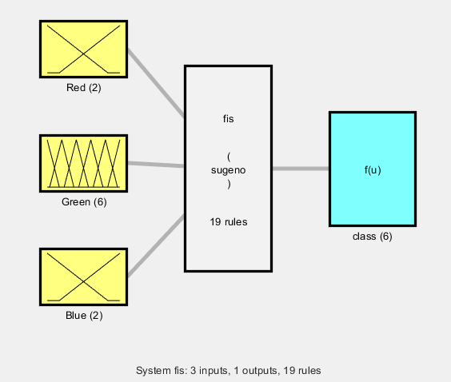For the Sugeno System we have this result:

Conclusion:

For this recognition the system can classify only half of the data but if we consider different class as a group. Like put the class 1 and 2 together the fuzzy system can reach good performances.